**KwickMeal, A restaurant management system**

B.Sc. (Hons.) Computing, Softwarica College of IT and E-commerce, Coventry University

Submitted by:

Kirtan Shrestha(ID: 13703598)

Submitted to:

Module Teacher (ST5009CEM Software Development)

**Table of Contents**

Introduction 3

Problem Statement 4

Agile Process 5

Role 10

Argument 13

Conclusion 17

Reference 19

Link 21

**Table of Figures**

Figure 1:Priority Set 5

Figure 2:User Stories Mapping 6

Figure 3: Agile Release Plan 7

Figure 4: Agile Spring Backlog 1 7

Figure 5: Agile Spring Backlog 2 7

Figure 6: Agile Spring Backlog 3 8

Figure 7: Agile Spring Backlog 4 8

Figure 8: Agile Spring Backlog 5 8

Figure 9: Agile Spring Backlog 6 9

Figure 10: Agile Spring Backlog 7 9

Figure 11: Agile Spring Backlog 8 9

Figure 12: Admin Panel 13

Figure 13: Menu Page 13

Figure 14: Add to Cart. 14

Figure 15: Khalti Payment Method. 14

Figure 16: Transaction History 15

Figure 17:MVT pattern 16

# Introduction

KwickMeal is a system designed to manage the restaurant effectively and smoothly. Making use of the Django framework, the application was constructed. This project is the result of the combination of the latest technology and fine dining to create an integrated platform that completely changes the dining experience for customers and staff members.

The goal of KwickMeal is to give customers a hassle-free experience. The user interface is simple to use, making the registration and login procedures quick and easy. Clients can safely complete purchases online, place orders, and quickly browse a large menu. Additionally, by giving customers the option to reserve tables for certain day, the system gives them greater authority over their eating experience.

Meanwhile, administrators have access to a complete dashboard that functions as a center for all restaurant activities. They can effectively manage and keep tabs on customer interactions, check the customer list, follow orders, and manage bookings here. The system's adaptability includes the capacity to add, update, and remove orders, reservations, and customer information, giving admins instant access to a dynamic and responsive control panel.

One of KwickMeal's best features is its menu management tools, which allow admins to easily add, update, or remove food items. This guarantees that the restaurant's menu will always be up to date and represent the newest culinary trends, resulting in a lively and interesting cuisine that suits changing customer preferences.

# Problem Statement

The KwickMeal project was started after a thorough examination of the ongoing difficulties that restaurant owners and customers have in the ever-changing restaurant industry. Traditional restaurant management techniques frequently fall short, resulting in inefficiencies, an absence of real-time data, and low customer involvement. Acknowledging the critical need for a vital solution, our passionate group started working on KwickMeal, utilizing the powerful Django framework to solve these problems facing the whole industry.

Effectively managing client contacts, tracking orders, and processing reservations are often challenging tasks for restaurants. In the absence of an organized system, difficult manual procedures are frequently used, which increases the risk of mistakes and lowers the quality of the entire dining experience. Booking reservations, placing orders, and navigating through large menus may be an exhausting and time-consuming endeavor for customers.

KwickMeal presents a thorough and technologically advanced platform that addresses these common issues. Customers may place orders quickly and easily, conduct safe online purchases, and reserve individual tables with ease because to the system's user-friendly interface. In addition, restaurant managers are granted access to an interactive dashboard that facilitates monitoring of orders, easy management of customer data, and real-time supervision of bookings. The menu management section of the platform makes sure that the restaurant's offers are updated on a regular basis to reflect the changing preferences of customers and modern trends in cuisine.

# Agile Process

The KwickMeal project's developers made the decision to use the Agile approach, specifically the Scrum methodology, for several reasons. Scrum's dynamic and iterative structure fits the needs of the project perfectly and makes teamwork among members of the team more effective.

Figure 1:Priority Set

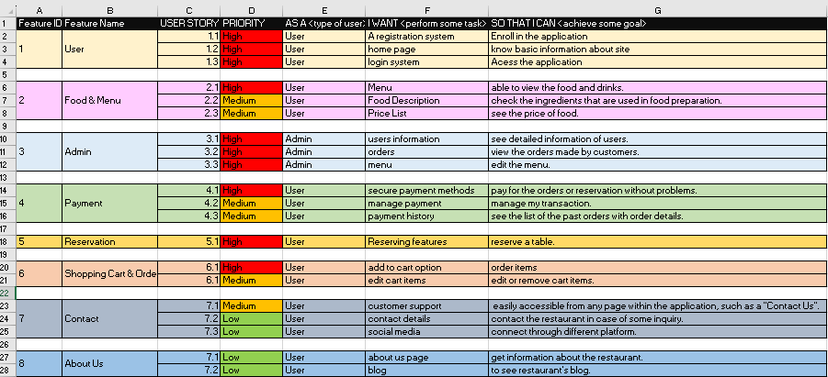

Since Scrum values flexibility, our team can react quickly to changing needs and adjustments to the project's structure. As the restaurant business is always evolving and we need to make quick adjustments to match the needs of customers, Scrum's iterative cycles, or sprints, allow us to continuously improve and develop KwickMeal's features.

Figure 2:User Stories Mapping

For the project, Scrum's focus on regular and open communication is essential. The daily stand-up meetings and frequent sprint reviews make sure that developers, designers, and stakeholders are kept up to date on the status of the project. This openness develops a common understanding of objectives and priorities, improves cooperation, and reduces the possibility of misunderstandings.

We can rapidly develop a prototype and give stakeholders and end users early benefits. Then, following sprints expand on the initial foundation, including feedback and iteratively improving the system. Scrum's focus on regular outputs and customer satisfaction guarantees KwickMeal's continued responsiveness to user needs. We can assign importance to features and make necessary adjustments depending on user preferences and new developments in the restaurant business by routinely collecting input during sprint reviews.

Figure 3: Agile Release Plan

Figure 4: Agile Spring Backlog 1

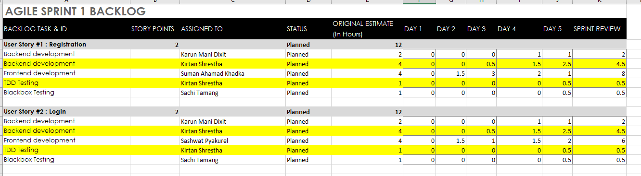

Figure 5: Agile Spring Backlog 2

Figure 6: Agile Spring Backlog 3

Figure 7: Agile Spring Backlog 4

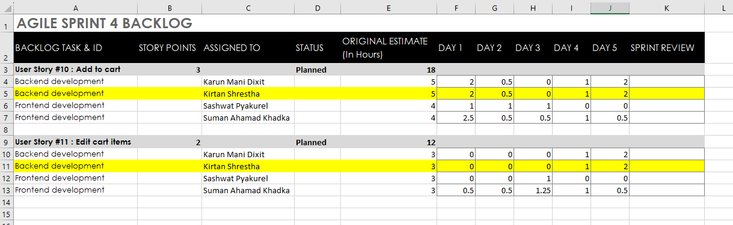

Figure 8: Agile Spring Backlog 5

Figure 9: Agile Spring Backlog 6

Figure 10: Agile Spring Backlog 7

Figure 11: Agile Spring Backlog 8

# Role

As a backend developer in the Kwickmeal project, my primary responsibility is to design, develop, and maintain the server-side logic and database architecture that powers the application. This involves implementing APIs, optimizing database queries for performance, ensuring data integrity and security, and integrating with other backend services or third-party APIs as needed.

Specifically, my role includes:

* Collaborating with frontend developers to define API contracts and ensure smooth communication between frontend and backend systems.
* Designing and implementing database schemas that support the application's data model and business logic.
* Writing clean, efficient, and well-documented code that follows best practices and coding standards.
* Implementing authentication and authorization mechanisms to secure access to sensitive data and functionalities.
* Working closely with DevOps or infrastructure teams to deploy and scale the backend infrastructure effectively.
* Participating in code reviews, troubleshooting issues, and providing technical support to other team members.

In my role as a backend developer, I believe in leading by example and fostering a collaborative and supportive team environment. Here are some ways in which I strive to motivate the team:

1. Clear Communication: I ensure that communication channels are open and transparent, allowing team members to express their ideas, concerns, and feedback freely. By actively listening to my teammates and providing clear and constructive feedback, I promote a culture of trust and mutual respect.
2. Recognition and Appreciation: I make an effort to recognize and appreciate the hard work and contributions of my colleagues. Whether it's acknowledging a job well done in a team meeting or giving shoutouts on our communication channels, I believe that recognizing individuals' efforts boosts morale and encourages continued dedication to the project.
3. Setting Achievable Goals: I work with the team to set realistic and achievable goals, breaking down larger tasks into manageable milestones. By celebrating small victories along the way, we maintain momentum and motivation, even when facing challenges.
4. Encouraging Growth and Learning: I encourage continuous learning and professional development within the team. Whether it's sharing relevant resources, organizing knowledge-sharing sessions, or providing mentorship to junior team members, I believe that investing in the growth of individuals ultimately benefits the team as a whole.
5. Team Psychology and Conflict Management: Understanding team psychology and effectively managing conflicts are crucial aspects of fostering a healthy and productive team dynamic. Here are some strategies I employ:
6. Building Trust: Trust is the foundation of any successful team. I prioritize building trust among team members by promoting open communication, respecting diverse perspectives, and honoring commitments. When team members trust each other, they are more likely to collaborate effectively and resolve conflicts constructively.
7. Encouraging Diversity of Thought: I value the diversity of experiences, backgrounds, and perspectives within the team. By actively seeking out and incorporating different viewpoints, we enrich our problem-solving processes and foster creativity and innovation. Additionally, creating an inclusive environment where everyone feels valued and respected contributes to overall team cohesion and morale.
8. Addressing Conflicts Proactively: Conflicts are inevitable in any team setting, but how they are managed can make all the difference. I encourage team members to address conflicts openly and respectfully, focusing on finding mutually beneficial solutions rather than assigning blame. By facilitating constructive discussions and mediating when necessary, we can resolve conflicts before they escalate and strengthen team relationships in the process.

# Argument

The implementation of the KwickMeal project has yielded tangible benefits by effectively addressing real-life challenges encountered by restaurant administrators. By providing robust tools for managing food and customer orders in real-time, KwickMeal empowers restaurant administrators to streamline their operations and enhance overall efficiency. With the ability to access and manage orders promptly, administrators can make informed decisions and adapt to changing circumstances swiftly, thereby improving the quality of service and customer satisfaction.

Figure 12: Admin Panel

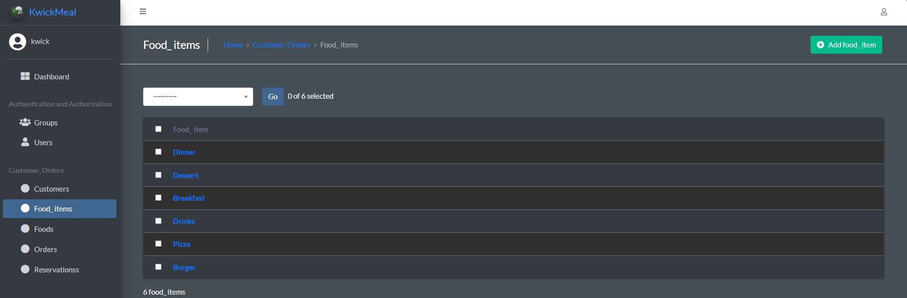

Figure 13: Menu Page

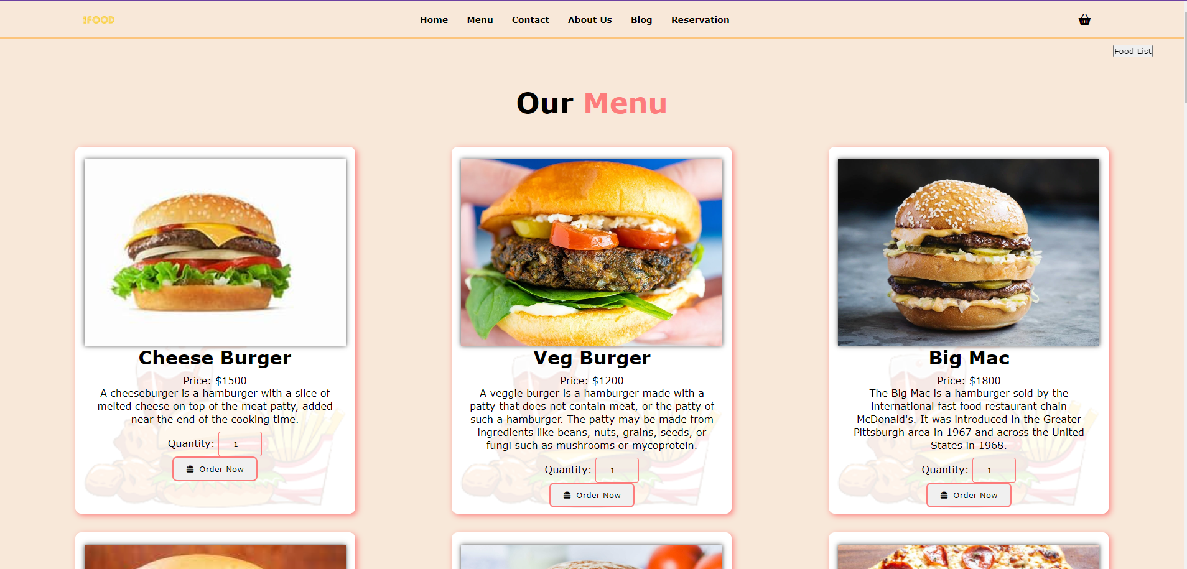

Moreover, KwickMeal facilitates secure online payment processing, mitigating concerns related to financial transactions and ensuring peace of mind for both restaurant owners and customers. By implementing stringent security measures, such as encryption protocols and secure payment gateways, KwickMeal safeguards sensitive financial information and instills trust in users, thereby fostering a conducive environment for conducting online transactions.

Figure 14: Add to Cart.

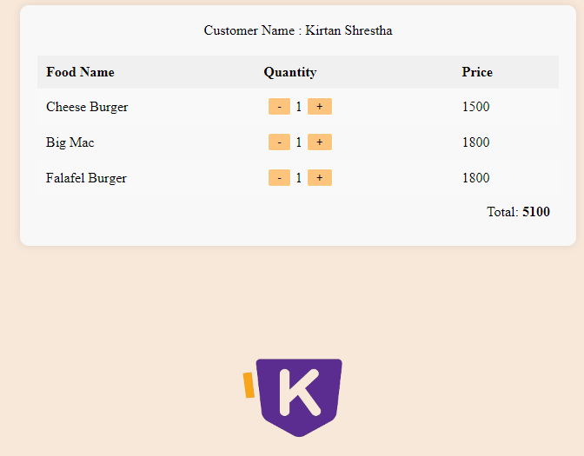

Figure 15: Khalti Payment Method.

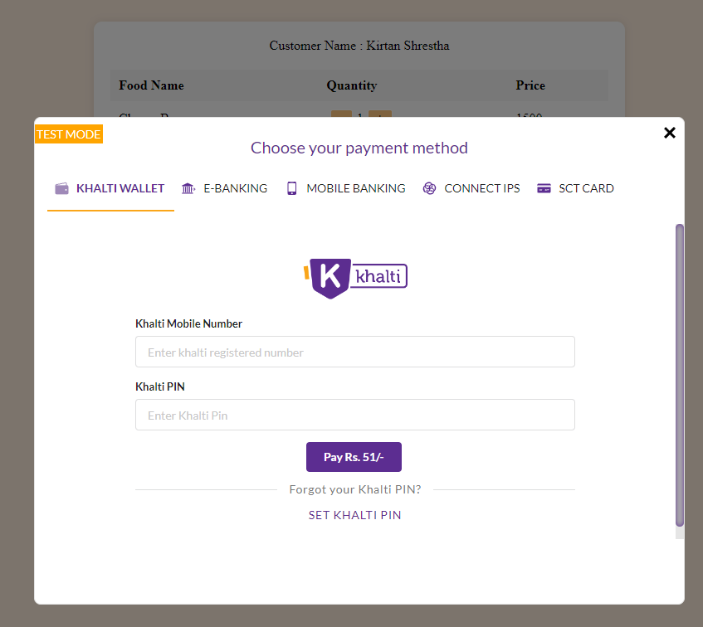

Figure 16: Transaction History

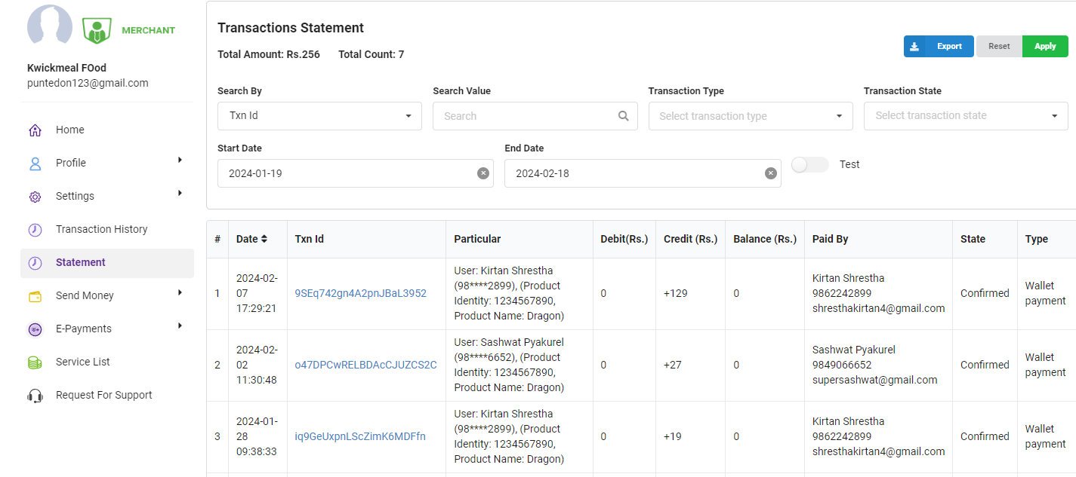

In the backend development of the KwickMeal project, my contributions were instrumental in facilitating key functionalities essential for seamless user experiences. I focused on implementing registration and login systems, ensuring secure access for both customers and administrators. Additionally, I played a vital role in designing and managing the admin panel, providing intuitive interfaces for administrators to add, modify, and track orders, reservations, and menu items efficiently. Furthermore, I integrated the 'Khalti' API for secure payment processing, enhancing the platform's reliability and trustworthiness. Overall, my backend development efforts significantly contributed to the project's success by enabling smooth registration and login processes, efficient order and reservation management, seamless menu updates, and secure payment transactions through the 'Khalti' API.

Figure 17:MVT pattern

# Conclusion

The KwickMeal project represents a significant advancement in the realm of restaurant management, offering a comprehensive solution to the challenges faced by both restaurant owners and customers. Through the integration of cutting-edge technology and innovative features, KwickMeal revolutionizes the dining experience, making it more efficient, convenient, and enjoyable for all parties involved.

By using the Django framework and adopting Agile methodologies, the development team has successfully created a robust and adaptable platform that meets the dynamic needs of the restaurant industry. The user-friendly interface simplifies registration, ordering, and reservation processes for customers, while the intuitive admin dashboard empowers restaurant administrators to efficiently manage operations in real-time.

Furthermore, the emphasis on security and data integrity ensures a safe and trustworthy environment for online transactions, enhancing user confidence and loyalty. The seamless integration of third-party APIs, such as 'Khalti' for payment processing, further enhances the platform's reliability and functionality.

As a backend developer, my role in the project was pivotal in implementing essential features, such as user authentication, database management, and payment integration, thereby contributing to the overall success and functionality of KwickMeal.

In conclusion, KwickMeal stands as a testament to the transformative power of technology in revolutionizing traditional industries. By providing a seamless and efficient platform for restaurant management, KwickMeal sets a new standard for excellence in the dining experience, ensuring customer satisfaction and operational efficiency. With its innovative features and commitment to quality, KwickMeal is poised to make a lasting impact in the restaurant industry for years to come.

# Reference

* *Django introduction - Learn web development | MDN*. (2024, January 1). MDN Web Docs. <https://developer.mozilla.org/en-US/docs/Learn/Server-side/Django/Introduction>
* GeeksforGeeks. (2023, September 6). *Django Tutorial*. <https://www.geeksforgeeks.org/django-tutorial/>
* Technology IT. (2021, July 4). *Adding Reserve table form in templates | Build a restaurant site with Python and Django* [Video]. YouTube. <https://www.youtube.com/watch?v=xcsbQHdtI2k>
* Python world. (2021, December 5). *#28. Cart Model || E-commerce website in django || Python World || Django* [Video]. YouTube. <https://www.youtube.com/watch?v=SAs-kvl-3gk>
* Python world. (2021b, December 8). *#29. Add To Cart || E-commerce website in django || Python World || Django* [Video]. YouTube. <https://www.youtube.com/watch?v=V3n_3ztmKzw>
* GeeksforGeeks. (2021, July 7). *How to create a login system in Python using Django? | Python Projects | GeeksforGeeks* [Video]. YouTube. <https://www.youtube.com/watch?v=1UvTNMH7zDo>
* Geeky Shows. (2021, February 2). *ShoppingLyX E-Commerce shopping Website complete Django Project (Hindi)* [Video]. YouTube. <https://www.youtube.com/watch?v=I6rR3Se72BU>
* CodeWithHarry. (2019, January 28). *Creating our first Django project | Python Django Tutorials in Hindi #2* [Video]. YouTube. <https://www.youtube.com/watch?v=weAUmhABjBc>
* *Walnut Bistro Nepal*. (n.d.). <https://walnutbistronepal.com/?fbclid=IwAR3nmwrgwoQzEpARjafgXZI9m8fP3YDVKxb4kxqiVf9vZOOLiifLDe3DCwk>
* *Django*. (n.d.). Django Project. <https://docs.djangoproject.com/en/5.0/>
* SuperSimpleDev. (2022, February 5). *HTML & CSS Full course - Beginner to Pro* [Video]. YouTube. <https://www.youtube.com/watch?v=G3e-cpL7ofc>
* GfG. (2024, February 13). *HTML tutorial*. GeeksforGeeks. <https://www.geeksforgeeks.org/html-tutorial/>
* GfG. (2024b, February 15). *CSS tutorial*. GeeksforGeeks. <https://www.geeksforgeeks.org/css-tutorial/>
* *Color palettes for designers and artists - Color Hunt*. (n.d.). <https://colorhunt.co/>
* Programming with Mosh. (2021, January 11). *HTML tutorial for beginners: HTML crash course* [Video]. YouTube. <https://www.youtube.com/watch?v=qz0aGYrrlhU>
* Bro Code. (2023, May 31). *HTML & CSS Full Course for free (2023)* [Video]. YouTube. <https://www.youtube.com/watch?v=HGTJBPNC-Gw>
* CodeWithHarry. (2019b, March 20). *Git & GitHub Tutorial for Beginners in Hindi - हिंदी में* [Video]. YouTube. <https://www.youtube.com/watch?v=gwWKnnCMQ5c>

# Link

* Trello: <https://trello.com/b/zj8DMDRP/kwickmeal>
* Github: <https://github.com/sachi-tmg/KwickMeal>
* Excel: <https://1drv.ms/x/s!AltS6U8xNxEsgeU6VfjYvSaSzj8ccA?e=f6EnPF>
* Youtube Video: <https://youtu.be/yj85eVxVfqw>